**Install pyserial on Raspbian**

python -version

If the pip command is available (run pip to see if return or not command not found bash) run (replace with pip2 and pip3 based on the python version used).

sudo install pyserial pip3

Otherwise through apt-get

sudo apt-get install python-serial python3-serial

**Free serial port**

Before going any further, check that the console is not listening on the serial port. To do this run

sudo raspi-config

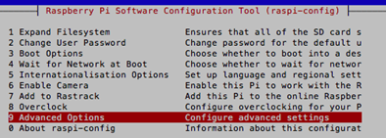

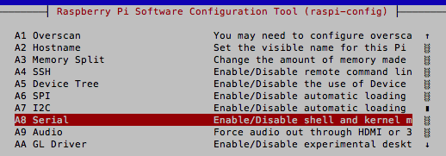

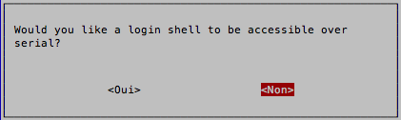

SERIAL IS NOW DISABLED !!!

**Find the ttyUSB port that corresponds to your device**

To determine the USB port to connect the unit to the USB port then run the command **dmesg -s 1024**.

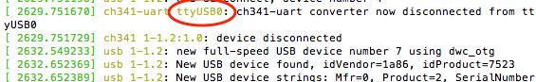

**Python code to read the serial port**

sudo nano read_serial.py

#!/usr/bin/env python

import time

import serial

ser = serial.Serial(

port='/dev/ttyUSB0',

baudrate = 9600,

parity=serial.PARITY_NONE,

stopbits=serial.STOPBITS_ONE,

bytesize=serial.EIGHTBITS,

timeout=1

)

counter=0

**while** 1:

x=ser.readline()

print x

To write

ser.write(“sssss”)

Now, launch the program to read messages sent on the serial port from your device (for example an Arduino).

sudo python read_serial.py

Reading the messages of a Gateway MySensors on the serial port of a Raspberry Pi.

To exit the program, make the combinations of keys Ctrl + C.